**Final Project-Problem Statement**

FitPro IncProvides an Online Solution about Dietary plans, Nutritional Values, Fitness Suggestions and Solutions. They want their solution to be A web based solution as well as accessible on Mobile Apps.This Particular Solution We focus only on Web Based Solution.A Single page App need to be built with multiple Flows

**There are two kinds of users for the app**

People belonging to

a.User group

b.Admin Group

Implement Required API and run it on JSON Servera.

1. Details of API will be sharedHost the image on the nginx server

**Single Page APP**

The app has two flows

Implement Logging Functionality , We use a Token based Authentication Implement Lazy Loading for Modules

**User Flow**:

We have to implement a routed user interface with multiple pages

1.Page containing Search for Food Products and Their nutritional Value

2.Page Displaying Dietary Plans and Benefits

3.Building a Dietary Plan and Find in the nutritional Benefits

4.Pages to communicate with platform to ask suggestion and get Responses

5.Forum page

**Admin Flow**

:1.We Can Add Products

2.We Can Respond to Suggestions Asked

The detailed Requirements for the User Flow and Admin Flow will be shared With detailed flow diagram.

**Project Workflow**

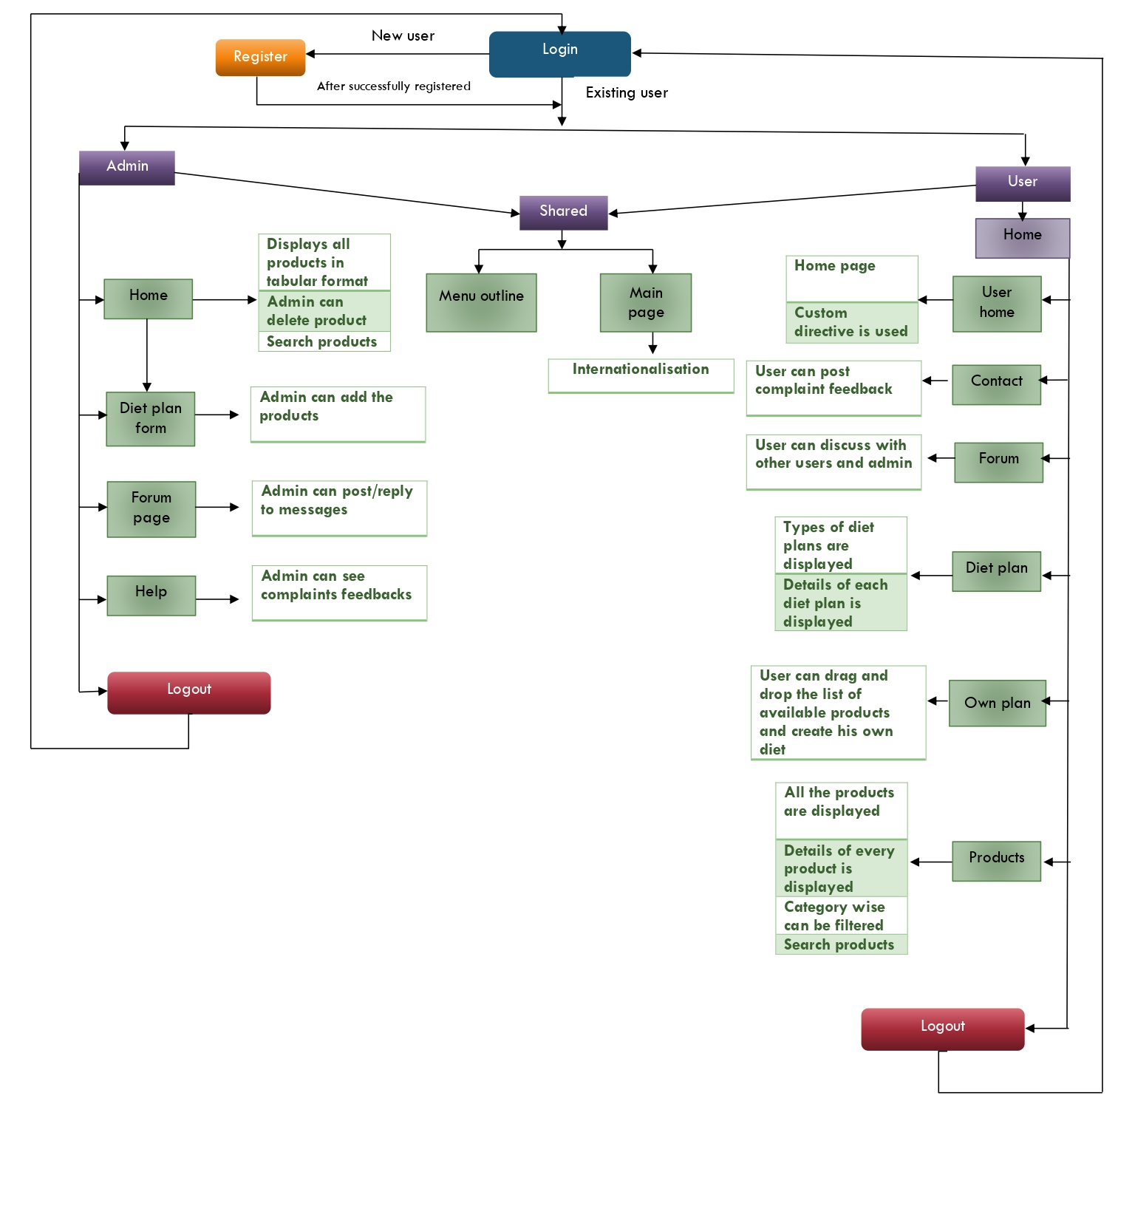

**Components workflow :**

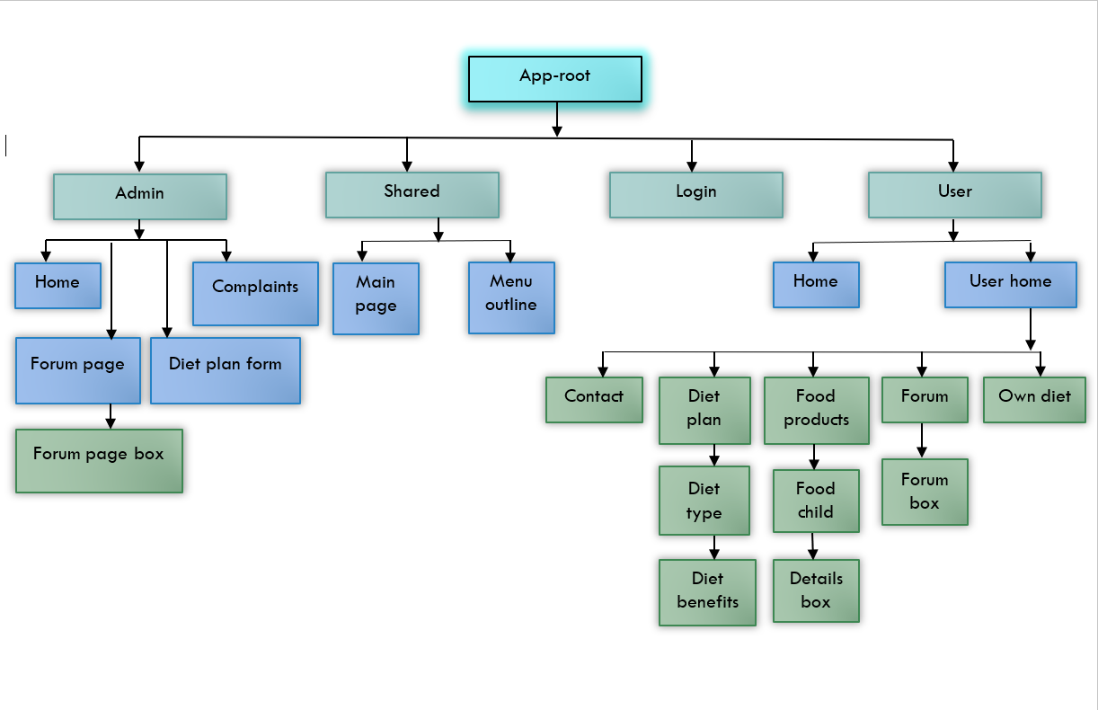

**Services Workflow:**

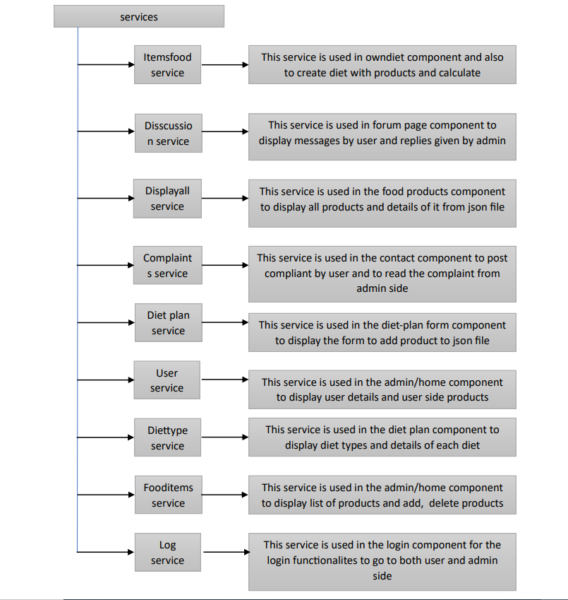

**Pipes workflow:**

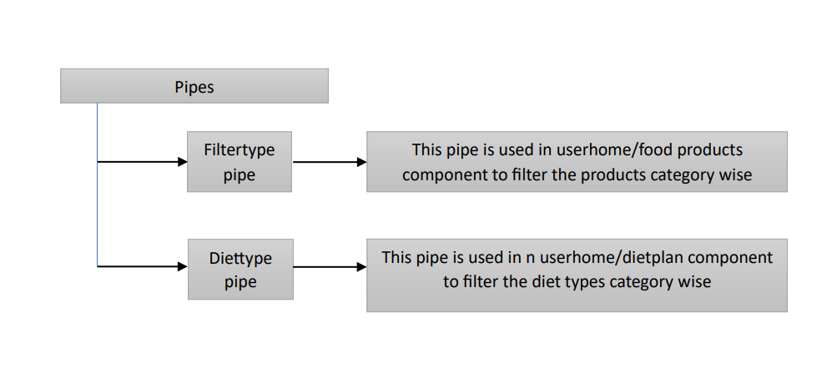

**Login Page:**

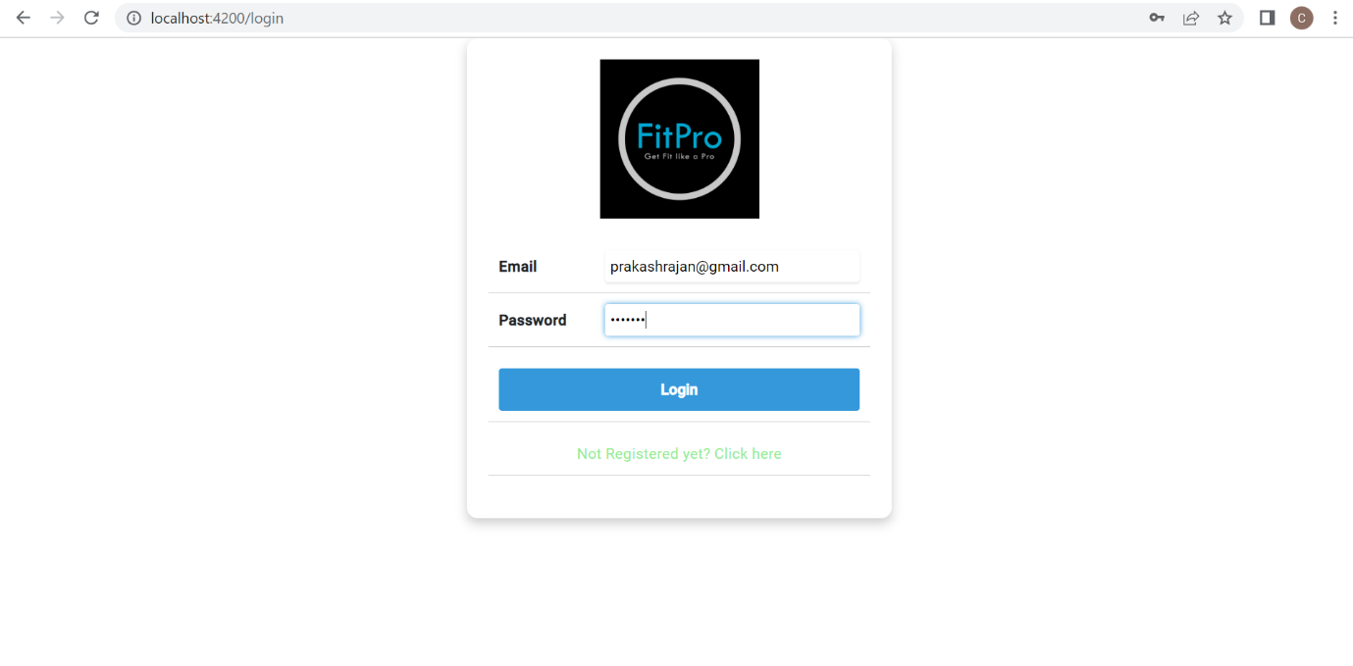

**Registration page:**

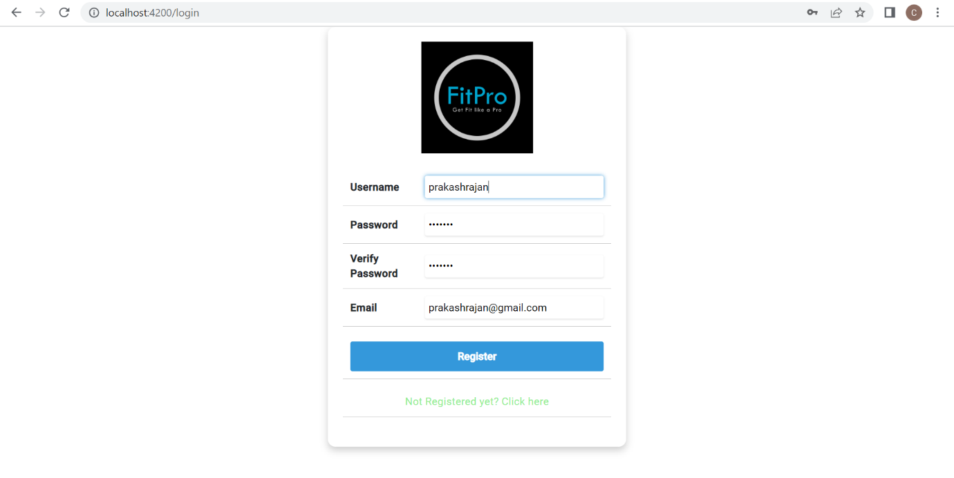

It is the login page where we can register if we are new user

If you are already registered then you can login with the user credentials

If you want to login as admin you need to Change type from user to admin in json file

**Validation also implemented in login page and register page.**

**User Flow:**

**Home page:**

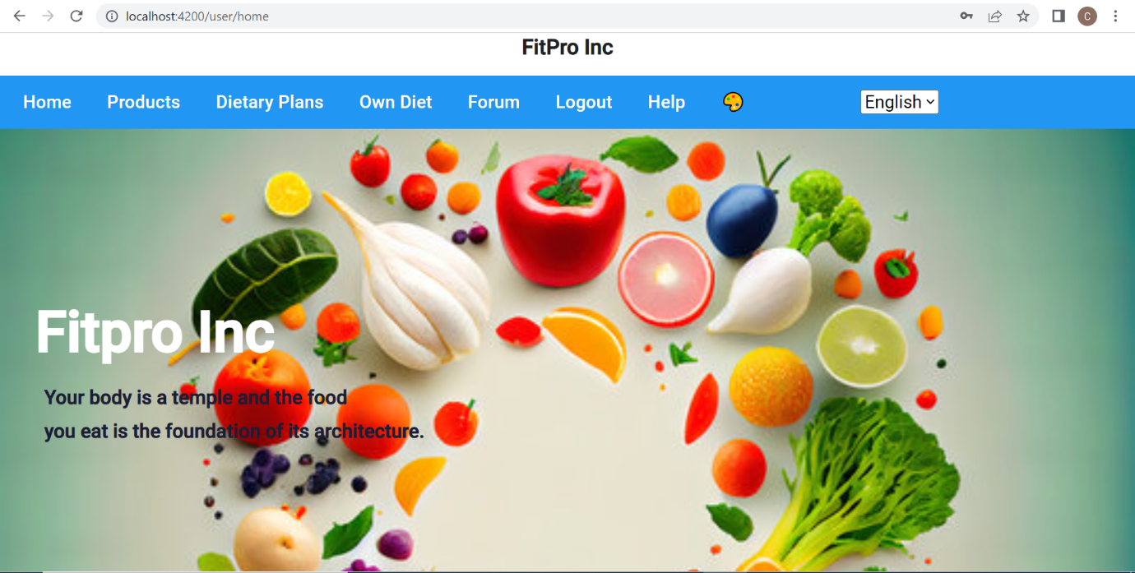

After logging in as user this homepage will appear

This homepage consists of components such as products ,dietary plans ,own diet ,forum logout option, complaints to be raised and theme changer and menubar translation

**Food products:**

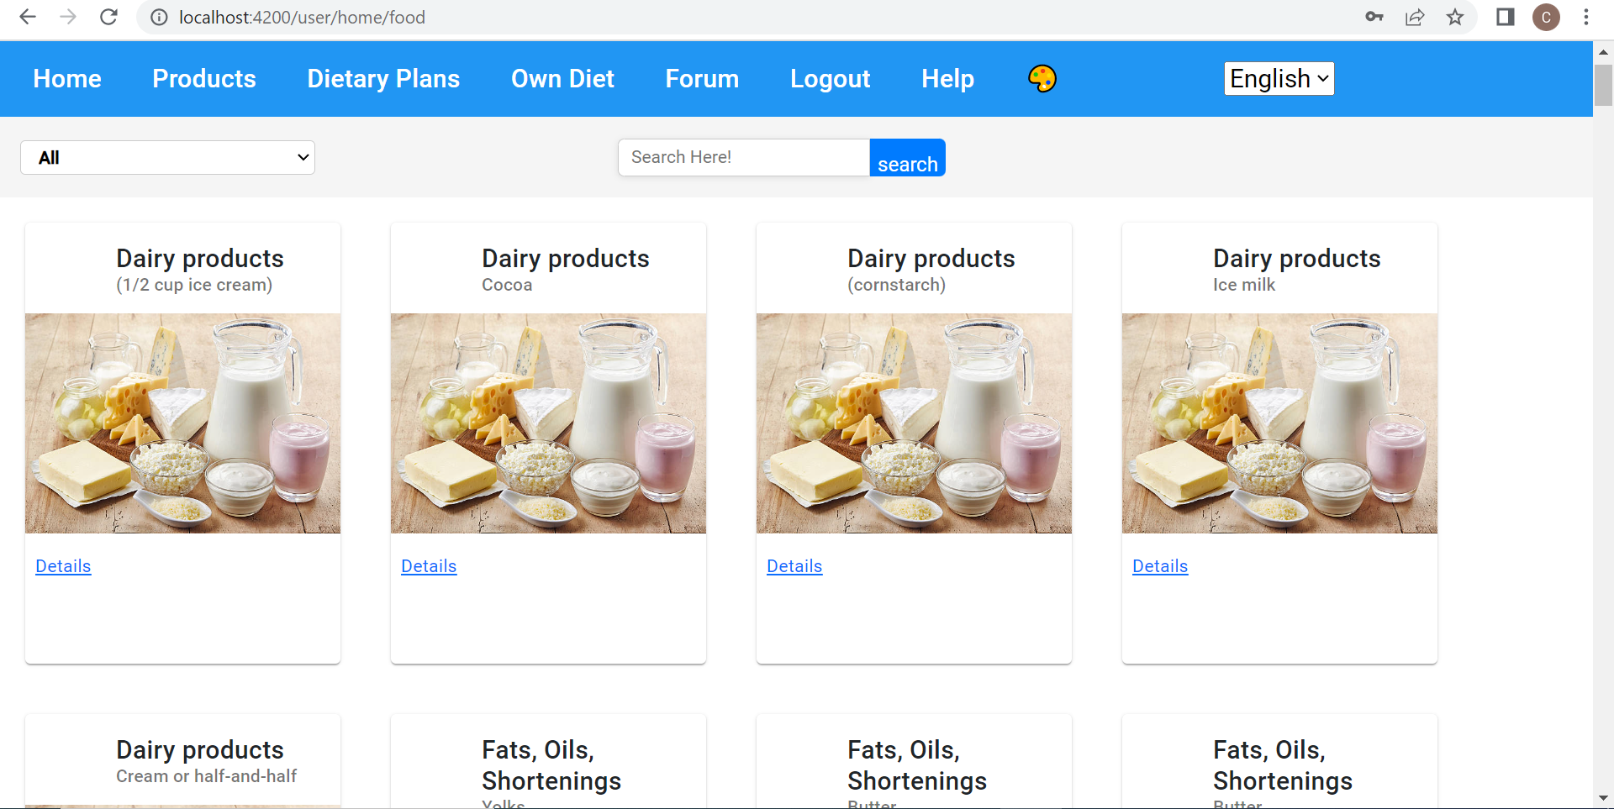

**Select category:**

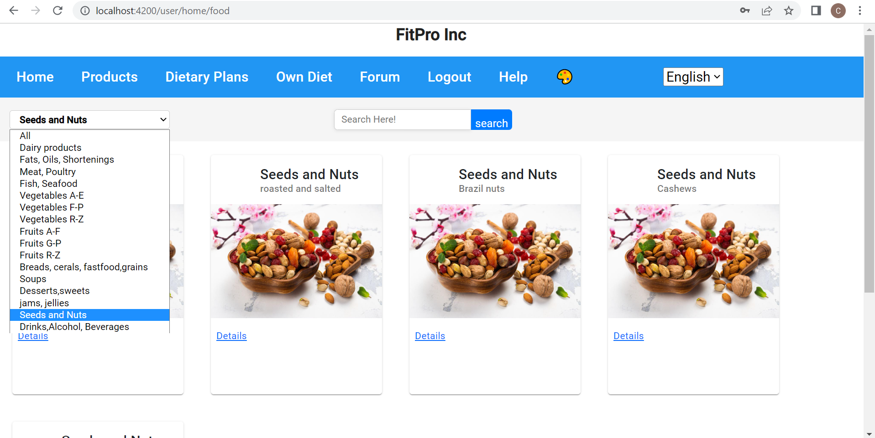 A homepage menu bar consists of products after clicking on that we get a products like all displayed in a page which is connected with routing

We have used pipes for filtering that category wise

we can also search whatever we required like particular product

**Details of product:**

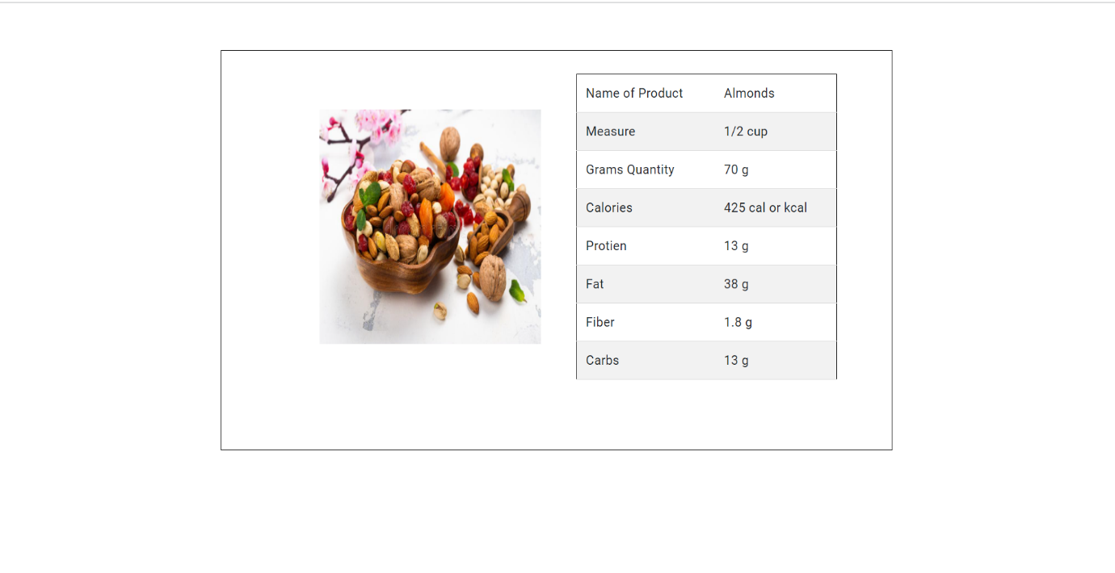

in the products page the products are displayed under which under each and every product there is a details option

after clicking on to that details button it takes to new page through routing where details of particular product is displayed

**Dietary plans:**

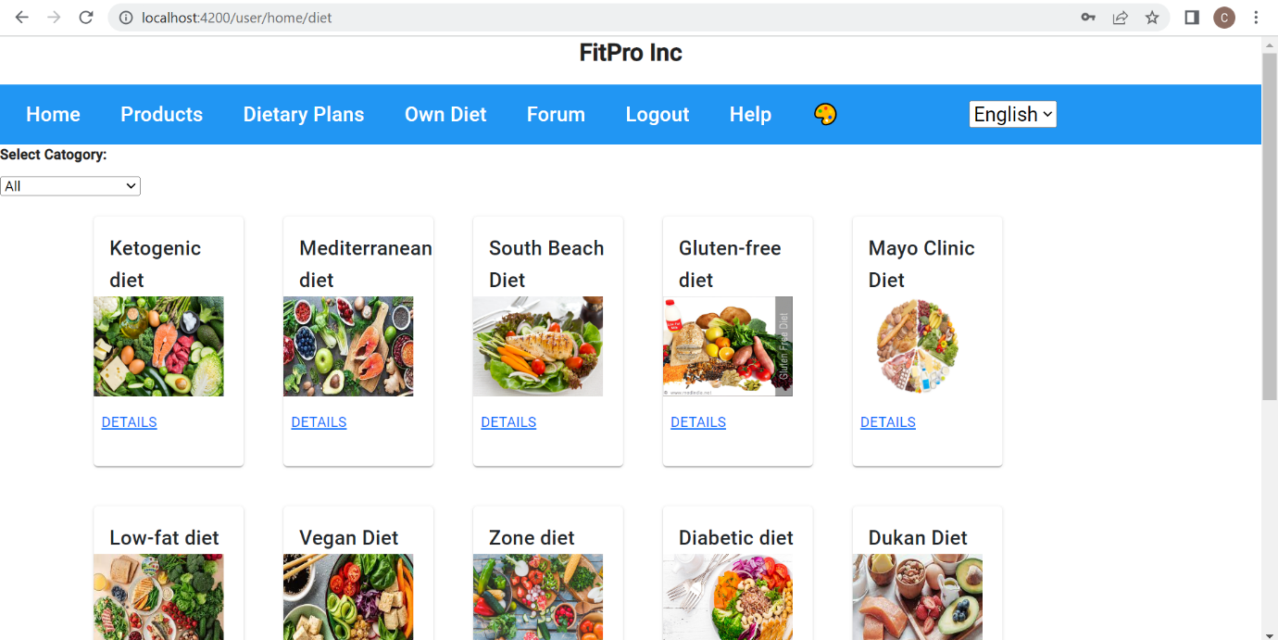

**Details of product:**

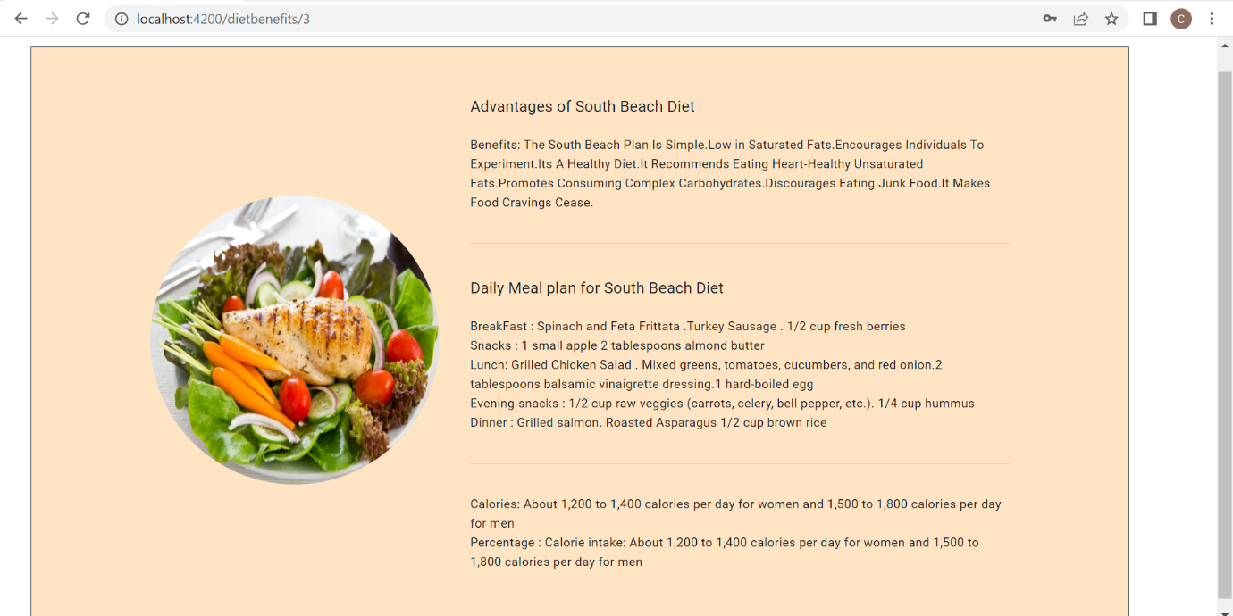

In home page after clicking on detail plans there is a page displayed news different types of diets are provided

On clicking details we get the details of each and every diet in which advantages of particular diet and diet meal per day according to that is included

**Create your Own Diet:**

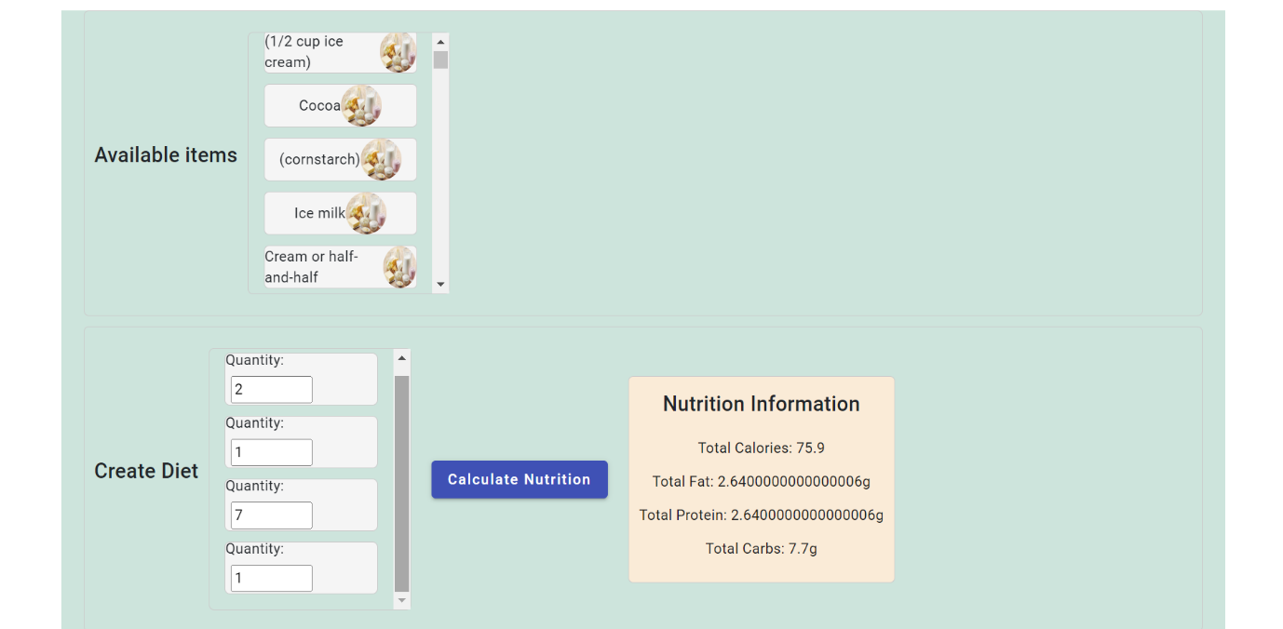

This page a user can create his own diet by using drag and drop option

there is a list of products displayed he can drag and drop to the place where quantity is calculated

after quantity is decided he can click on the calculate nutrition button it calculates the nutrition value

**Complaints:**

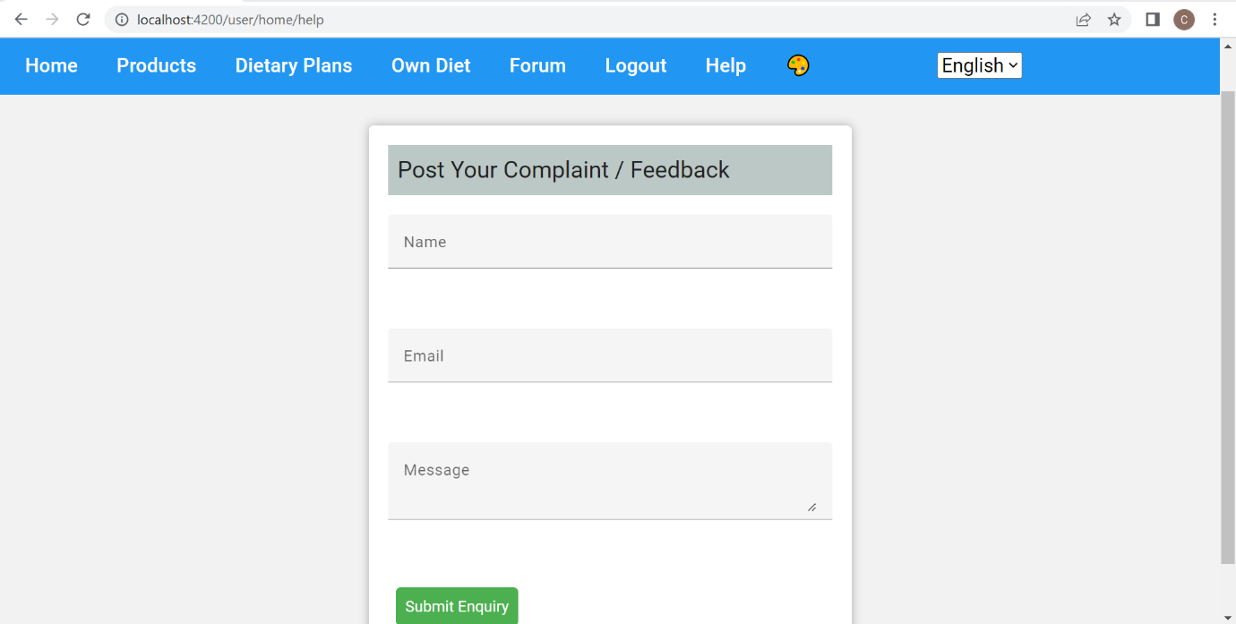

On clicking on help it takes to complaints page

here we can post our complaints queries and feedbacks to the website which can be seen by admin

**Forum page**

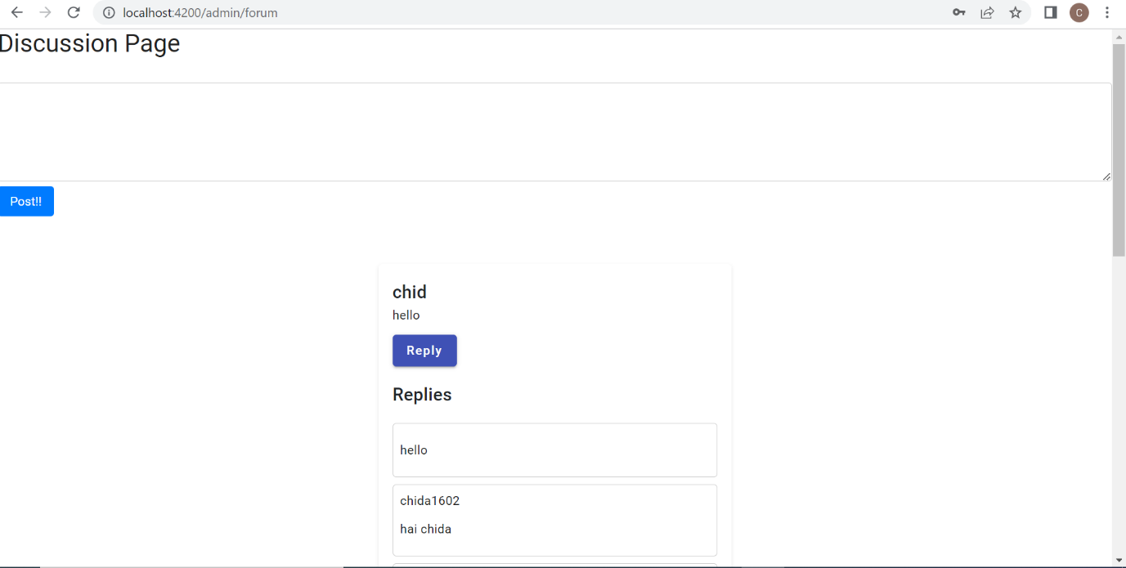

The forum is a discussion page where admin and users can interact

here a user can post his query or feedback or suggestion so that admin can reply to that

**Admin flow:**

**Homepage**

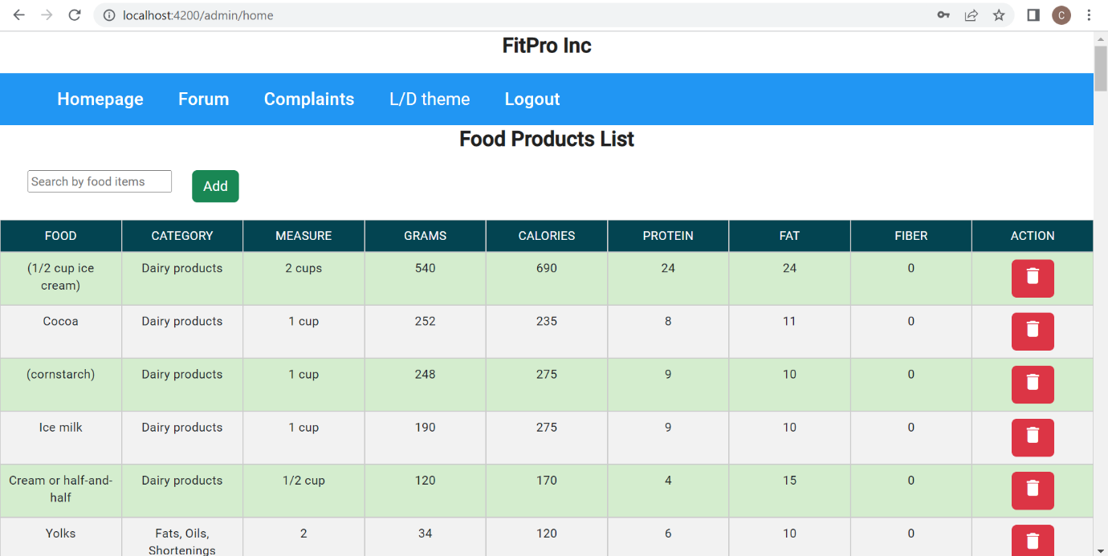

**Add products**

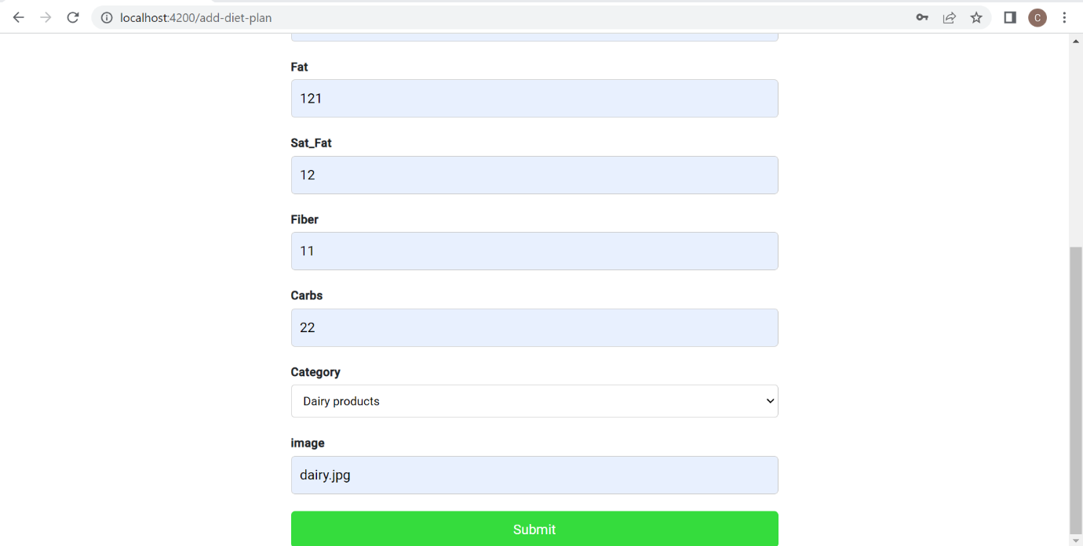

After logging as admin with admin credentials takes to a home page where all food products is displayed in a table

here admin can add and delete the products

admin can Search the products in the search bar

clicking on add it takes to form page where we can fill the details of the product

in that page we used the **model based form with validation**

**complaints page:**

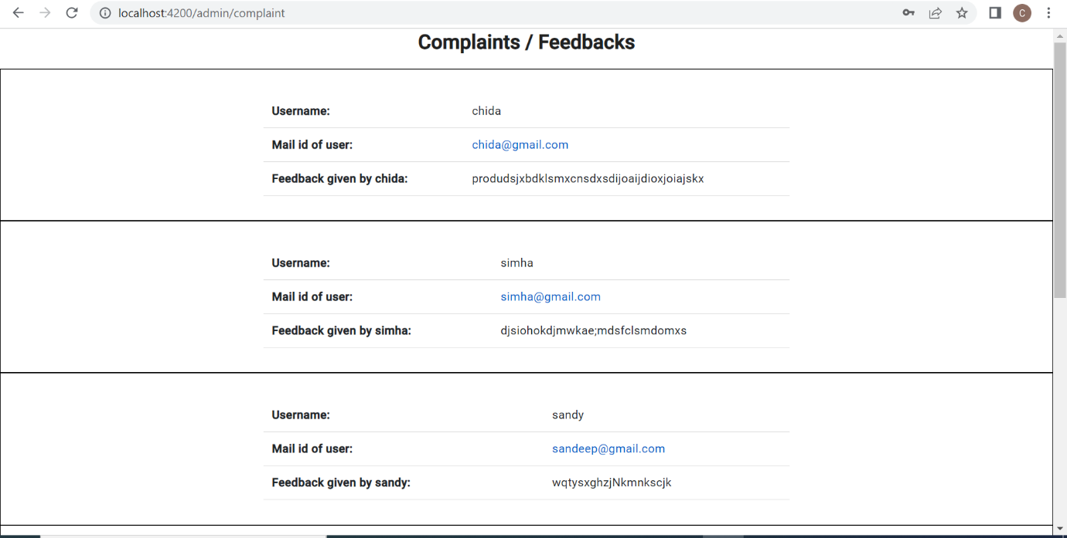

In admin side menu bar consists of complaints on clicking it takes to a page where complaints and feedbacks were displayed which was posted by user

here admin can read the complaints and reply to the user mail on clicking his mail id it will take to compose mail page

**Discussion page:**

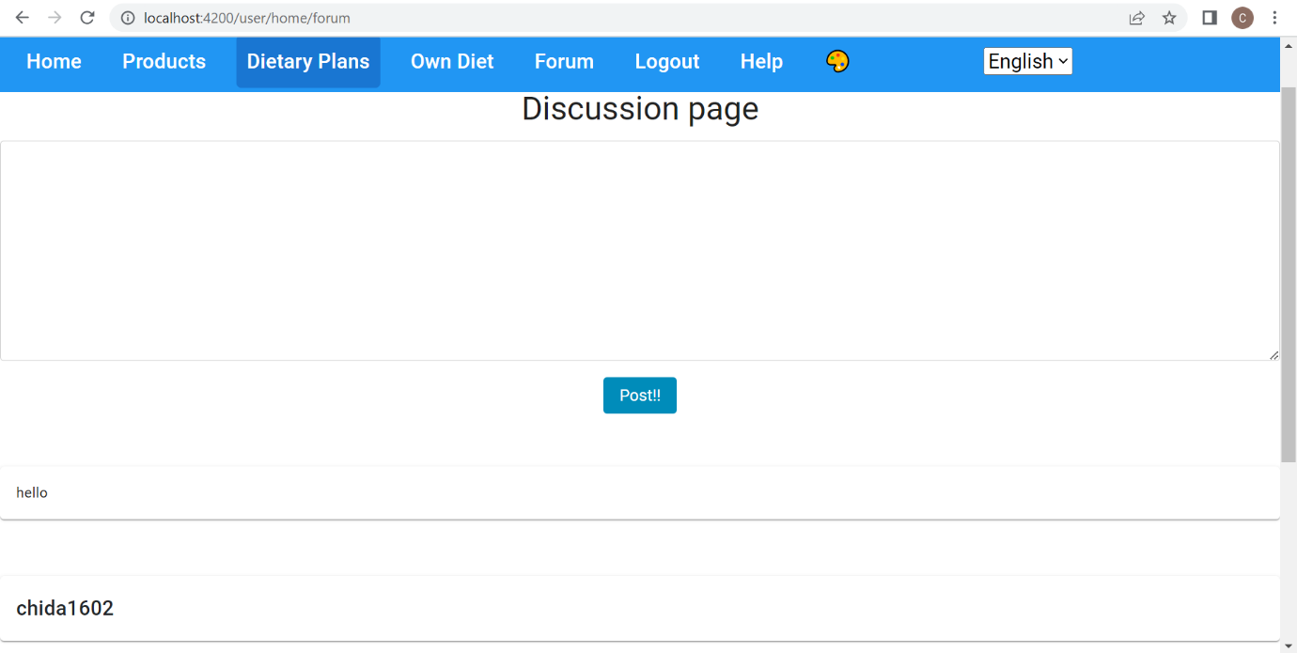

it is a discussion page where admin also can post whatever he want

admin also can reply to the users comments

**Darktheme/light Theme on both admin side,User side and login page**

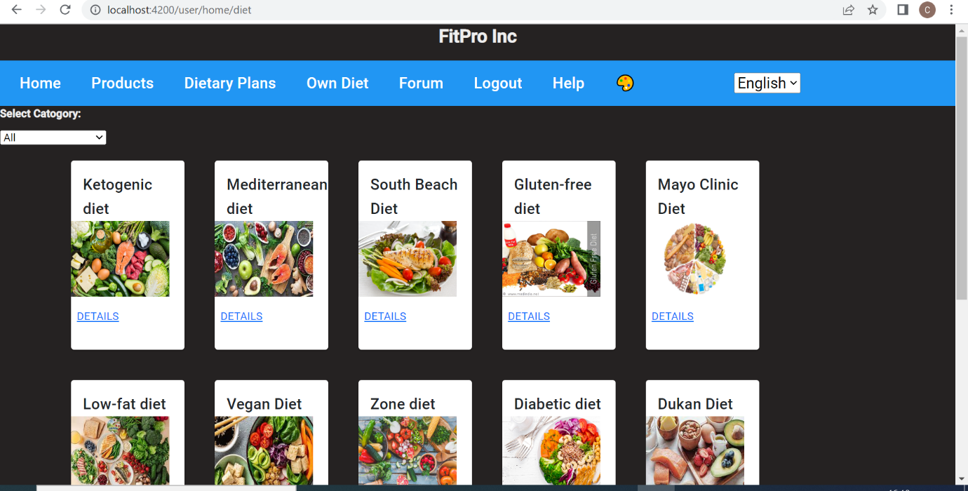

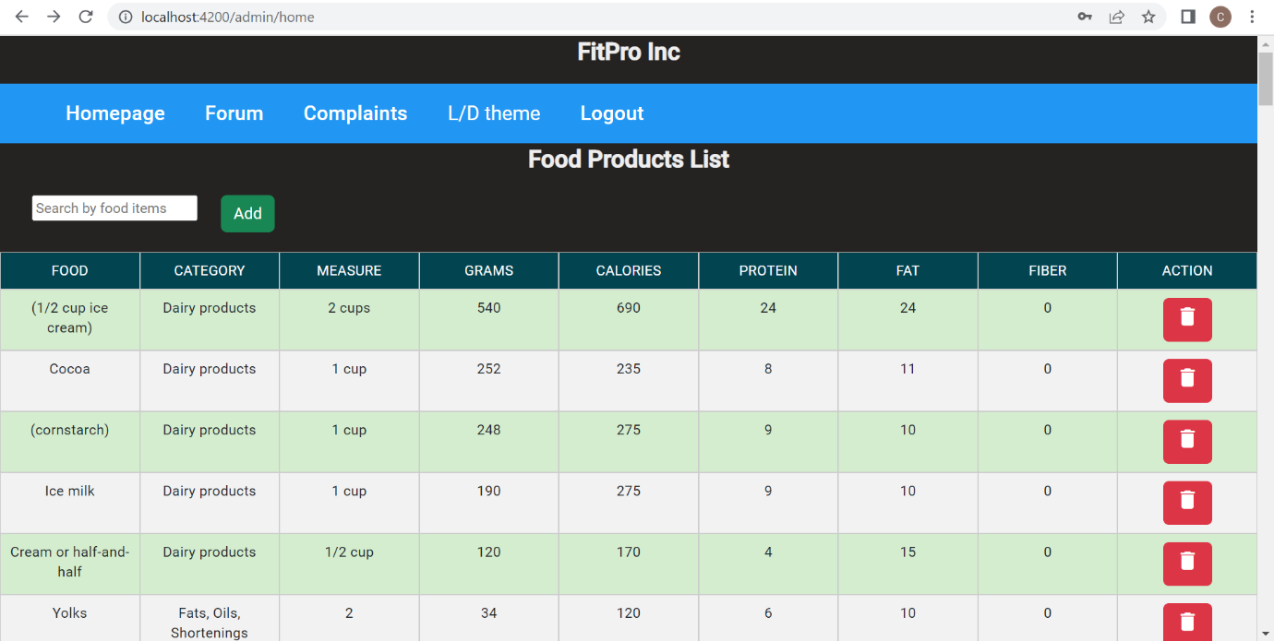

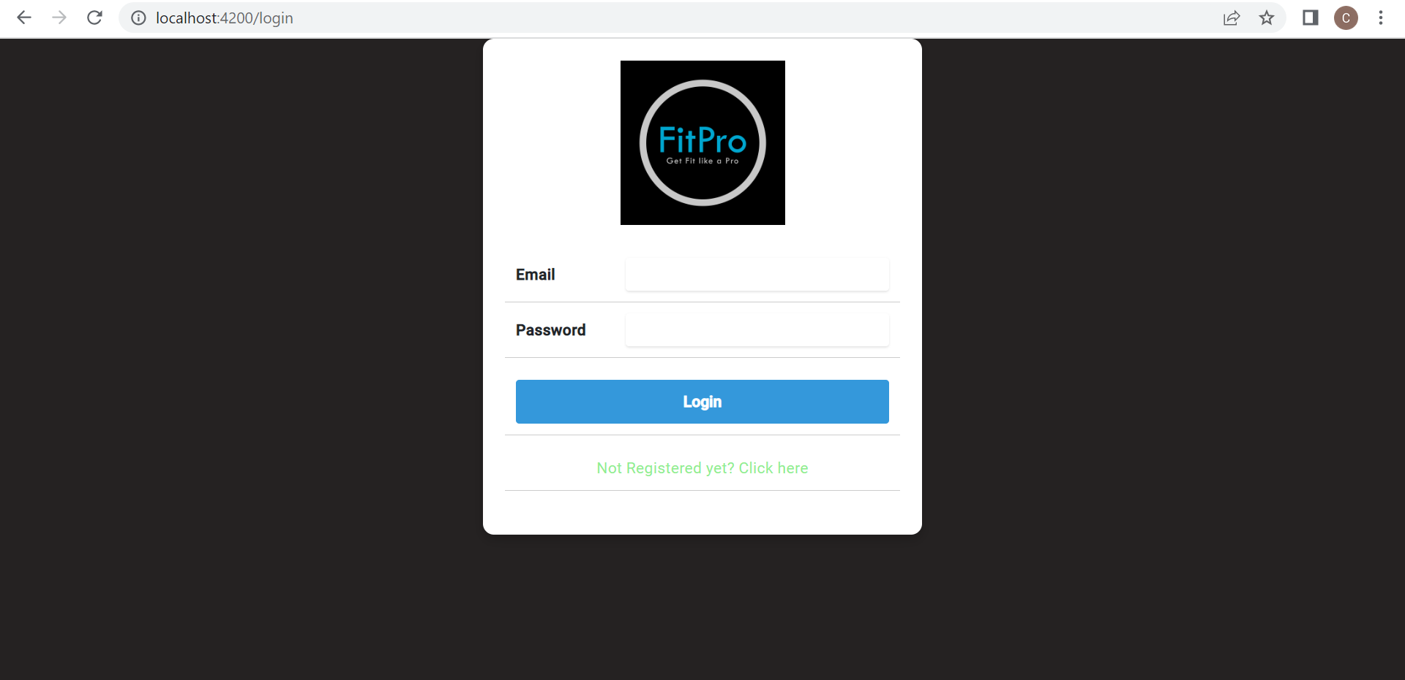

In all login page, admin and user side we can change the dark theme to light theme and from light theme to dark theme

**Interanationalisation:**

Menubar in tamil

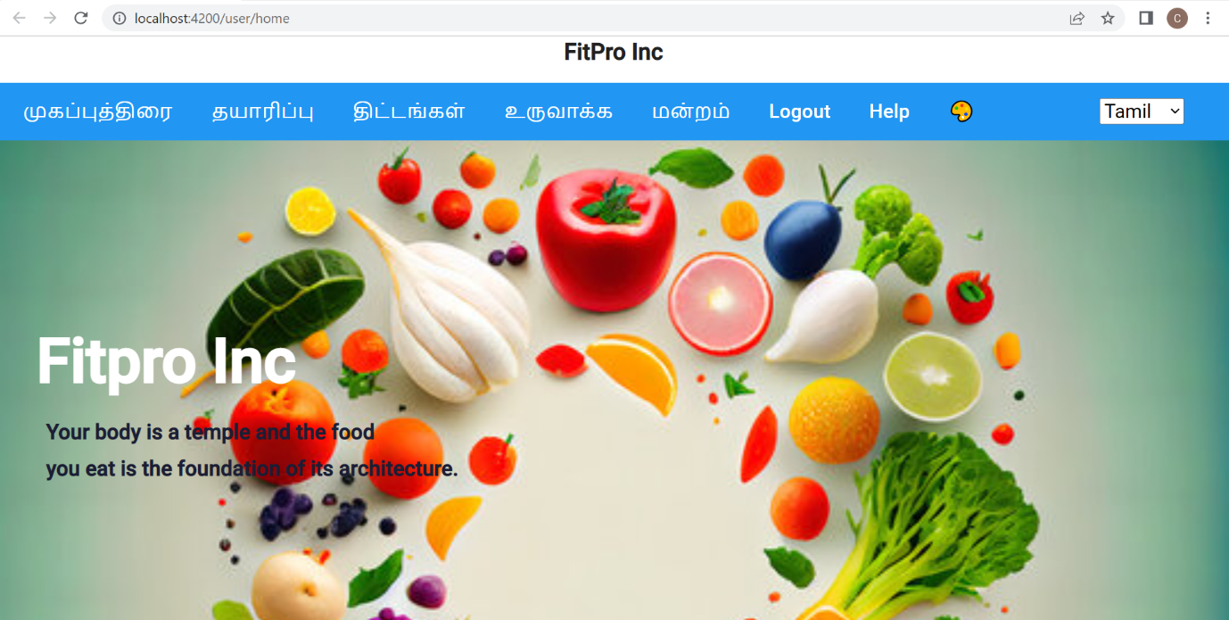

Menubar in telugu

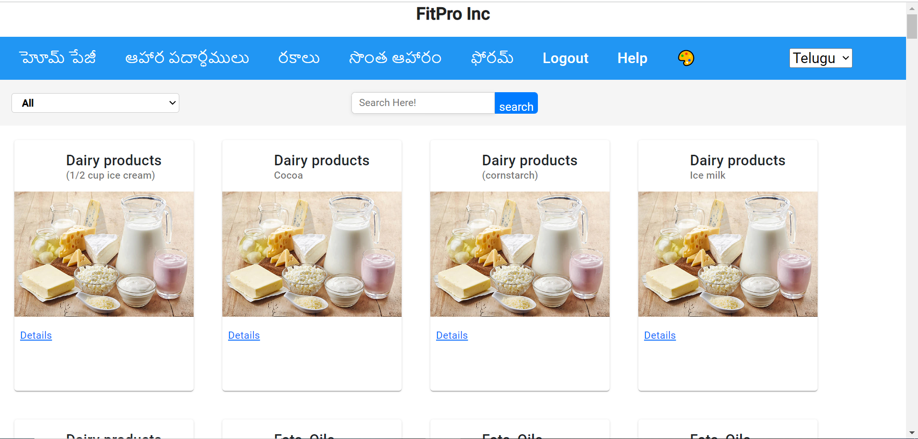

Menubar in Hindi

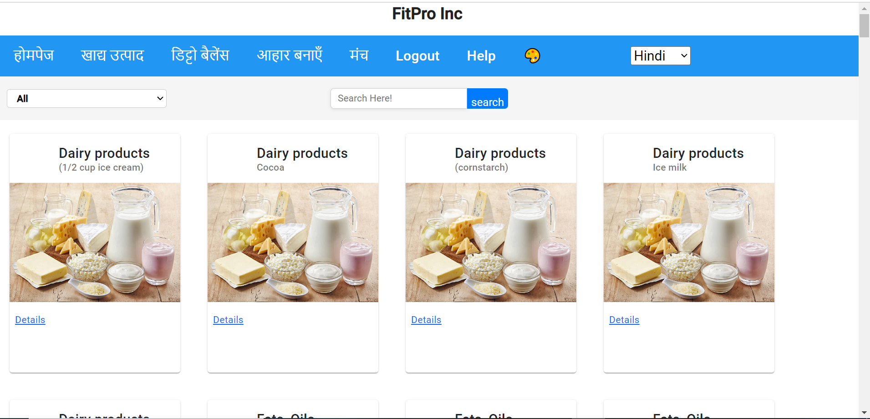

User side user side I have implemented internationalization using ngx translation

there is a option that menu bar can be displayed in Telugu Hindi English and Tamil languages

**Custom Directives:**

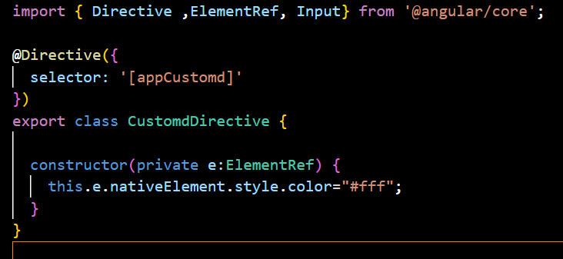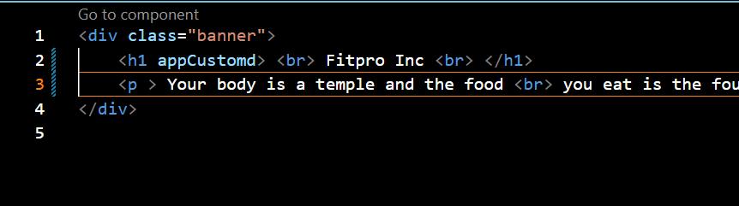

directive is created named as customd

in that customd Directive.ts I have written a function for styling an element

In user home html I have implemented H1 tag . in H1 tag I have used app custom

Here we can see that fit Pro is displayed in white colour using custom directive method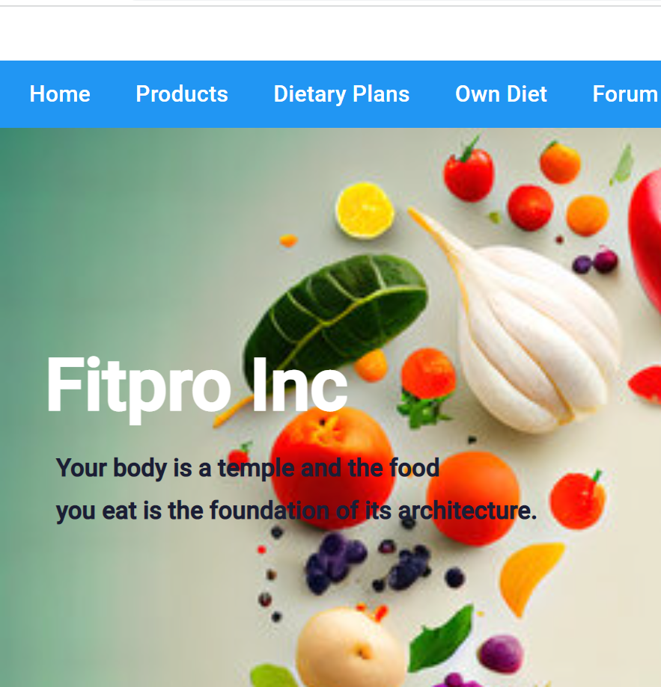

**Security Implementation:**

We have used the session storage for storing the registration credential details

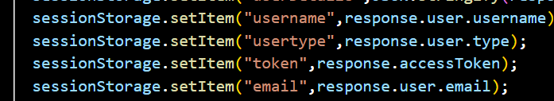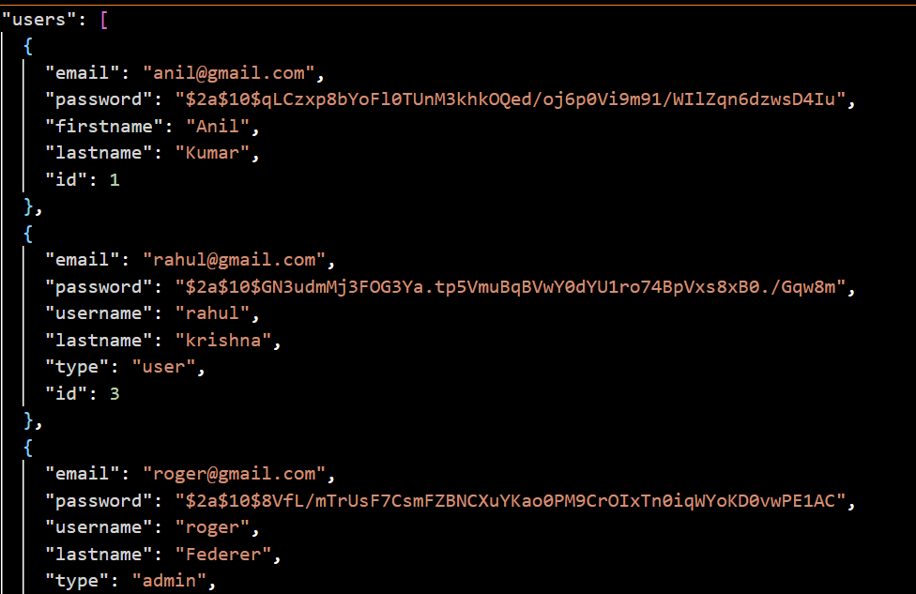

Here in the login component.ts we have used session storage for registration credentials

Here the credentials like password is saved in json as token-based as shown in above picture

**Logout implementation**

Finally on clicking the logout option it will redirect to login page from both admin and user side.